CLOUD-BASED FINANCIAL TRANSACTION PATTERN ANALYTICS
A Project Report Submitted in the partial fulfillment of the
requirements for the award of the degree of

BACHELOR OF TECHNOLOGY
In
DEPARTMENT OF COMPUTER SCIENCE ENGINEERING

By
M.Sahithi Reddy- 2420030424
Y. Anuhya– 2420030514
Under the Esteemed Guidance of

LECTURE NAME PRATHUSHA BONAGANI



K L (Deemed to be) University

DEPARTMENT OF COMPUTER SCIENCE ENGINEERING


Declaration

The Project Report entitled "Retail Sales Forecasting with Seasonal Trends" is a record of Bonafide work of team members M.Sahithi Reddy – 2420030424, Anuhya – 2420030514, submitted in partial fulfilment for the award of B. Tech in Computer Science Engineering to KLH.The results embodied in this report have not been copied from any other departments/University/Institute.

M.Sahithi Reddy-2420030424

Anuhya-2420030514
K L (Deemed to be) University DEPARTMENT OF COMPUTER SCIENCE ENGINEERING


Certificate

This is to certify that the project-based report entitled "Retail Sales Forecasting with Seasonal Trends" is a Bonafide work carried out and submitted by [Names and Roll Numbers], in partial fulfilment of the requirements for the award of the degree of Bachelor of Technology in Computer Science Engineering, at [University Name], during the academic year [2025–2026.

Signature of the Supervisor

Signature of the HOD Signature of the External Examiner

ACKNOWLEDGEMENT
The success of this project would not have been possible but for the timely help and guidance rendered by many people. We wish to express our sincere thanks to all those who assisted us in one way or another for the completion of this project.
Our greatest appreciation goes to our guide, Dr.PRATHUSHA BONAGANI, Department of Computer Science, whose tremendous support, encouragement, and guidance made this project possible.
We express our gratitude to Mr.Venkateshwar Rao, Head of the Department of Computer Science Engineering, for providing us with adequate facilities, ways, and means by which we could complete this project.
We thank all members of the teaching and non-teaching staff who assisted us directly or indirectly in the successful completion of this project. Finally, we sincerely thank our parents, friends, and classmates for their kind help and cooperation during this work.

M.Sahithi Reddy-2420030424

Anuhya-2420030514

TABLE OF CONTENTS

S.No | Contents | Page no
1 | Abstract | 6
2 | Introduction | 7
3 | Literature survey | 9
4 | Hardware and Software requirements | 12
5 | Implementation | 16
6 | Experimentation and Code | 18
7 | Results | 21
8 | Conclusion | 24
19 | References | 25

ABSTRACT
Retail businesses generate continuous streams of sales data across products, categories, and time periods, and accurately forecasting future sales is critical for inventory planning, staffing, and marketing decisions. Traditional forecasting relying on manual spreadsheet analysis is time-consuming, error-prone, and fails to account for seasonal fluctuations and promotional effects. This project, titled "Ledger — Retail Sales Forecasting with Seasonal Trends," presents a self-contained, browser-based forecasting dashboard that enables retail stores to predict monthly sales using historical data, seasonal indices, and promotional activity.
The system is built as a single-page web application using HTML, CSS, and JavaScript, with Chart.js powering all data visualizations. Users can upload their own transaction data via CSV (containing date, category, units sold, revenue, and promotion flags), or rely on built-in sample data to explore the tool's features. The forecasting engine combines a seasonal-naive method with a linear trend adjustment, allowing the model to project 3, 6, or 12 months ahead while accounting for recurring seasonal patterns and adjustable promotional boost percentages.
The dashboard presents key metrics such as total revenue, growth rate, and top-performing categories, alongside interactive charts showing a 24-month sales history with promotional periods highlighted, category-wise breakdowns, and a seasonal index chart. A scenario simulator allows users to model the impact of adding promotions in specific months or adjusting marketing spend, comparing projected outcomes against a baseline forecast. Results can be exported as CSV or printed as PDF reports.
The project demonstrates that lightweight, client-side analytics — without requiring a backend server or cloud infrastructure — can still deliver meaningful, interactive forecasting capabilities suitable for small and medium-sized retail businesses.

INTRODUCTION

In the retail industry, sales are rarely constant throughout the year — they rise and fall in response to seasons, holidays, promotional campaigns, and shifting consumer behavior. Retailers who fail to anticipate these fluctuations often face stockouts during peak demand or excess inventory during slow periods, both of which directly impact profitability. Accurate sales forecasting therefore plays a central role in inventory management, staffing decisions, marketing planning, and overall business strategy.
The project titled "Ledger — Retail Sales Forecasting with Seasonal Trends" addresses this need by providing an accessible, self-contained forecasting tool that a retail store can use without specialized data science expertise or expensive enterprise software. The system analyzes historical sales data to identify seasonal patterns and trends, then projects future sales for a configurable forecast horizon.
Problem Description and Objectives
Retail stores commonly rely on basic spreadsheets or intuition to estimate future demand, which fails to systematically capture seasonal effects (e.g., holiday spikes) or quantify the impact of promotions. As product catalogs and historical datasets grow, manual analysis becomes increasingly impractical, and the lack of a structured forecasting approach leads to inefficient inventory and marketing decisions.
This project aims to solve that problem by building a browser-based dashboard that:
- Allows users to upload historical sales data (date, category, units sold, revenue, promotion flag) via CSV, with fallback sample data for exploration.
- Computes key business metrics: total revenue, month-over-month and year-over-year growth, and top-performing product categories.
- Visualizes 24 months of historical sales, with promotional months clearly highlighted, alongside category breakdowns and a seasonal index chart.
- Implements a forecasting engine combining seasonal-naive and linear trend methods to project sales 3, 6, or 12 months into the future, with adjustable promotion boost assumptions and confidence bands.
- Provides a scenario simulator so users can test "what-if" situations, such as adding a promotion in a specific month or increasing marketing spend, and compare the result against a baseline forecast.
- Supports exporting forecast results as CSV or printable PDF reports for offline use and sharing.
By combining an intuitive dashboard interface with a lightweight but effective forecasting model, the project demonstrates how small and medium retail businesses can gain data-driven insight into future sales without relying on costly infrastructure or specialized software

LITERATURE SURVEY

Sales forecasting has long been a critical area of research in retail operations and supply chain management. As retail businesses increasingly digitize their transaction records, the opportunity to apply systematic, data-driven forecasting methods — rather than relying on manual estimation — has grown substantially. Several established techniques and tools inform the design of this project.

Time-Series Forecasting Methods

Classical time-series forecasting techniques, including moving averages, exponential smoothing, and seasonal-naive methods, remain widely used in practice due to their simplicity, interpretability, and low computational cost. The seasonal-naive method, which assumes that a future period will resemble the same period from a prior seasonal cycle (e.g., this December resembles last December), is particularly effective for retail data with strong recurring seasonality such as holiday shopping spikes. Combining this with a linear trend component allows the model to also account for gradual, sustained growth or decline in overall sales, producing forecasts that are both seasonally aware and trend-aware without the complexity of models like ARIMA or Prophet.

Seasonality and Promotional Effects in Retail

Retail sales are strongly influenced by seasonal cycles (holidays, back-to-school periods, weather-driven demand) and short-term promotional events (discounts, flash sales, bundled offers). Research in retail analytics consistently shows that ignoring these factors leads to systematic forecasting errors — under-forecasting during promotional or peak seasonal periods and over-forecasting during off-peak periods. Incorporating a seasonal index (representing the relative demand multiplier for each month) and an adjustable promotional boost factor, as implemented in this project, allows the forecasting model to more closely reflect real-world demand patterns.

Client-Side Data Analytics
With the maturity of modern JavaScript libraries such as Chart.js, D3.js, and PapaParse, complex analytical dashboards can now be built entirely client-side, without requiring a backend server or database. This approach reduces infrastructure cost and complexity, and is well suited to small businesses that need a lightweight, portable tool rather than an enterprise data platform. Client-side CSV parsing and in-browser computation also mean that sensitive business data need not leave the user's device unless explicitly exported.
Interactive Scenario Simulation
Decision-support literature emphasizes the value of "what-if" scenario tools that let business users interactively test the impact of changes — such as adding a promotion or adjusting marketing spend — before committing resources. Rather than presenting a single static forecast, tools that allow parameter adjustment and immediate visual feedback support better-informed, more confident business decisions.
Data Visualization for Decision-Making
Effective visualization — bar charts, line charts, and index charts — plays a central role in making forecasting outputs interpretable to non-technical business users. Highlighting promotional periods on historical charts and displaying confidence bands on forecasts allows users to quickly grasp both past patterns and the uncertainty inherent in future projections.

Conclusion
The literature supports the approach taken in this project: a seasonal-naive plus linear trend model provides an effective balance between simplicity and accuracy for retail forecasting, while a fully client-side architecture makes the tool accessible and lightweight. This project applies these established principles in a practical, self-contained dashboard tailored to retail sales forecasting.

HARDWARE AND SOFTWARE REQUIREMENTS
Hardware Specifications
The Ledger retail sales forecasting system is a lightweight, browser-based application and does not require specialized or high-end hardware, since all computation runs client-side in JavaScript.
Processor: An Intel Core i3 processor or equivalent is sufficient to run the application smoothly. An Intel Core i5 or higher is recommended for better performance when working with larger CSV datasets.
RAM: A minimum of 4 GB RAM is required to run a modern web browser and render interactive charts. 8 GB RAM or above is recommended for smoother performance with larger datasets or multiple browser tabs open.
Storage: Minimal local storage is required, as the application is a single self-contained HTML file. At least 200 MB of free disk space is sufficient for browser cache and temporary files.
Graphics: No dedicated graphics card is required. Integrated graphics available on modern processors are sufficient for chart rendering.
Operating System: The application is compatible with Windows, Linux, and macOS, since it runs entirely within a web browser and does not depend on the underlying operating system.
Software Requirements
Development Environment:
- Visual Studio Code (or any text/code editor)
- Modern web browser (Google Chrome, Microsoft Edge, or Firefox) for testing and running the dashboard
Core Technologies:
- HTML5, CSS3, and JavaScript (ES6+) for the application structure, styling, and logic
- Chart.js — for rendering line charts, bar charts, and seasonal index visualizations
- PapaParse (or equivalent CSV parsing logic) — for handling drag-and-drop CSV uploads
Forecasting Logic:
- Custom JavaScript implementation of a seasonal-naive and linear trend forecasting model, executed entirely client-side
Optional Tools (for documentation and presentation):
- Python 3.x with python-pptx — used to generate the accompanying project presentation
- wkhtmltoimage — used to capture dashboard screenshots for documentation and slides
Browser Requirements:
- Any modern browser supporting HTML5, CSS3, and ES6 JavaScript (Chrome, Edge, Firefox, Safari)
With the above configuration, the Ledger dashboard can be run and tested efficiently on virtually any modern computer, without requiring backend servers, cloud subscriptions, or specialized data science infrastructure — making it highly accessible for small and medium retail businesses.

IMPLEMENTATION
Implementation of the Ledger Retail Sales Forecasting System
The implementation of the Ledger project focuses on building a fully self-contained, browser-based dashboard that enables retail businesses to analyze historical sales and generate seasonally aware forecasts. Unlike cloud-based analytics systems, Ledger performs all computation client-side using JavaScript, requiring no backend server, database, or external API.
1. Data Representation and Dataset Description
The dataset used by the system consists of monthly retail transaction records, either uploaded by the user via CSV or generated as built-in sample data. Each record includes:
- Date — the month/period of the transaction
- Category — the product category
- Units Sold — number of units sold in that period
- Revenue — total revenue generated
- Promotion Flag — indicates whether a promotion was active during that period
2. Application Architecture
The application is structured as a single HTML file containing four main functional modules:
- Dashboard Module — computes and displays summary metrics (total revenue, growth rate, top categories) and renders the 24-month historical sales chart with promotional periods highlighted, category breakdown chart, and seasonal index chart.
- Upload Data Module — handles drag-and-drop CSV upload, parses the file, validates columns, and falls back to built-in sample data if no file is provided.
- Forecast Module — implements the seasonal-naive plus linear trend forecasting model, with adjustable forecast horizon (3, 6, or 12 months) and promotion boost percentage, and renders actual vs. forecasted sales with confidence bands.
- Scenario Module — allows users to simulate adding a promotion in a chosen month or adjusting marketing spend, and compares the resulting projection against the baseline forecast.
3. Data Loading and Preprocessing
When a CSV file is uploaded, it is parsed in-browser and validated against the expected schema (date, category, units_sold, revenue, promotion). Missing or malformed rows are handled gracefully, and if no valid file is supplied, the system automatically falls back to a built-in sample dataset so the dashboard remains functional for demonstration purposes.
4. Forecasting Engine
The core forecasting logic combines two components:
- Seasonal-Naive Component — computes a seasonal index for each month based on historical data, capturing recurring patterns such as holiday-driven demand spikes.
- Linear Trend Component — fits a simple linear trend across historical periods to capture sustained growth or decline independent of seasonality.
These two components are combined to produce the base forecast, which is then adjusted upward based on the user-specified promotion boost percentage for any months flagged as promotional. Confidence bands are calculated around the forecast to visually communicate uncertainty.
5. Scenario Simulation
The scenario simulator re-runs the forecasting engine with modified inputs — such as an added promotion in a specific month, or an adjusted marketing spend multiplier — and renders the resulting projection alongside the original baseline forecast for direct comparison.
6. Visualization
All visualizations are rendered using Chart.js:
- Line chart for 24-month historical sales with promotional months highlighted
- Bar chart for category-wise revenue breakdown
- Line/index chart for seasonal index values
- Combined actual-vs-forecast chart with confidence bands
7. Export and Reporting
Users can export forecast results as a CSV file or generate a print-friendly PDF report directly from the browser's print functionality, allowing forecasts to be shared or archived outside the application.
8. Output and Performance
The application runs entirely in the browser with no network dependency after initial load, providing instant feedback as users adjust forecast parameters or scenario inputs. This client-side architecture ensures fast responsiveness and eliminates the need for server infrastructure, making the tool lightweight and easy to deploy or distribute as a single file.

EXPERIMENTATION AND CODE
Code Structure
The project was implemented using HTML, CSS, and JavaScript as a single self-contained file. The code consists of the following main parts:
- Data Loading: CSV parsing logic reads uploaded transaction data into in-memory JavaScript arrays/objects, or loads built-in sample data if no file is provided.
- Data Preprocessing: Validates and formats records, computes derived monthly aggregates (revenue, units sold, growth rates).
- Analysis Module: Computes dashboard metrics such as total revenue, growth percentage, and top-performing categories.
- Forecasting Logic: Implements the seasonal-naive plus linear trend model, calculates seasonal indices, applies promotion boost adjustments, and computes confidence bands.
- Scenario Simulation Logic: Re-computes forecasts under modified assumptions (added promotions, adjusted marketing spend) for comparison against the baseline.
- Visualization: Chart.js configurations render the historical sales chart, category breakdown, seasonal index chart, and forecast chart.
Steps Performed
- Designed the CSV schema (date, category, units_sold, revenue, promotion) and built the upload/parsing logic with sample-data fallback.
- Built the dashboard metrics computation (total revenue, growth, top categories).
- Implemented the 24-month historical sales chart with promotional periods visually highlighted.
- Built the category breakdown chart and seasonal index chart.
- Implemented the seasonal-naive + linear trend forecasting engine with adjustable horizon (3/6/12 months) and promotion boost percentage.
- Added confidence bands to the actual-vs-forecast chart.

- Built the scenario simulator to compare promotion/marketing-spend scenarios against the baseline forecast.
- Implemented CSV export and print-to-PDF reporting functionality.
- Tested the dashboard across sample datasets to confirm forecasting logic and visualizations rendered correctly.
Performance Analysis
- Processing Speed: Instantaneous, since all computation runs client-side in JavaScript with no network round-trips.
- Scalability: Handles typical retail dataset sizes (hundreds to a few thousand rows) smoothly within the browser.
- Accuracy: The seasonal-naive plus trend model closely tracked historical seasonal patterns in testing with sample data.
- Resource Usage: Minimal — the entire application runs within a single browser tab with no backend or database dependency.
Conclusion of Experimentation
Testing confirmed that a lightweight, client-side forecasting approach can effectively capture seasonal retail sales patterns without requiring cloud infrastructure or server-side processing. The dashboard responded instantly to changes in forecast horizon, promotion boost, and scenario parameters, providing a smooth, interactive user experience suitable for non-technical retail users.

RESULTS

Results of the Ledger Retail Sales Forecasting Project

The implementation of the Ledger dashboard produced meaningful results that demonstrate the effectiveness of a lightweight, client-side approach to retail sales forecasting.

1. Dashboard Metrics and Historical Analysis

The system successfully computed and displayed key metrics including total revenue, month-over-month and year-over-year growth, and top-performing product categories. The 24-month historical sales chart clearly distinguished promotional periods from regular sales periods, making seasonal spikes and promotional impact visually apparent.

2. Forecasting Accuracy and Behavior

The seasonal-naive plus linear trend forecasting model successfully projected future sales across 3, 6, and 12-month horizons. The model appropriately reflected recurring seasonal patterns (e.g., higher projected sales in historically strong months) while also capturing the underlying growth or decline trend in the data. Confidence bands provided a visual indication of forecast uncertainty, widening appropriately for longer horizons.

3. Scenario Simulation Outcomes

The scenario simulator effectively demonstrated the projected impact of adding a promotion in a specified month or adjusting marketing spend, showing a clear visual comparison against the baseline forecast. This allowed for quick evaluation of different planning strategies without requiring manual recalculation.

4. Visualization and Usability

All visualizations — the historical sales chart, category breakdown, seasonal index chart, and forecast chart — rendered correctly and clearly using Chart.js. The dashboard's card-based layout and color scheme presented data in an accessible, business-friendly format suitable for non-technical retail users.

5. Export and Reporting

The CSV export and print-to-PDF functionality worked as intended, allowing forecast results to be saved or shared outside the browser environment.

6. Learning Outcomes

Through this project, the following key learnings were achieved:

Practical understanding of time-series forecasting techniques (seasonal-naive and linear trend methods)

Hands-on experience building interactive data visualizations using Chart.js

Understanding of client-side CSV parsing and in-browser data processing

Experience designing scenario-based decision-support tools

Appreciation for the trade-offs between lightweight client-side analytics and full cloud-based data platforms

Final Overview

The results demonstrate that Ledger successfully achieves its objective of providing an accessible, self-contained retail sales forecasting tool. Without requiring any backend infrastructure, the system delivers meaningful seasonal and trend-based forecasts, interactive scenario simulation, and clear visual reporting — making it a practical solution for small and medium retail businesses seeking data-driven sales planning.

CONCLUSION
The Ledger — Retail Sales Forecasting with Seasonal Trends project successfully demonstrated that effective, interactive sales forecasting can be delivered through a lightweight, fully client-side web application, without reliance on cloud infrastructure or backend servers. By combining a seasonal-naive forecasting method with a linear trend adjustment, the system was able to generate sales projections that account for both recurring seasonal patterns and sustained growth trends.
Through the implementation of an intuitive dashboard, the project showcased how retail businesses can analyze historical sales by category, location of promotional impact, and overall growth, while also projecting future sales across flexible time horizons. The scenario simulator added a valuable layer of decision-support functionality, enabling users to test the impact of promotions or marketing spend changes before committing resources.
The use of Chart.js for visualization made complex data patterns easy to interpret, while CSV upload and export functionality ensured the tool could integrate smoothly into existing retail data workflows. The project also emphasized the practicality of client-side analytics — demonstrating that meaningful forecasting capabilities do not always require heavy infrastructure, and can instead be delivered as a single, portable, easily distributable file.
Overall, the project successfully met its objectives by providing a practical, accessible tool for retail sales forecasting. It highlights the value of combining simple, interpretable statistical methods with strong interactive visualization to support real-world business decision-making. This work serves as a solid foundation for future enhancements, such as integrating more advanced forecasting models (e.g., ARIMA or Prophet), supporting multi-store data aggregation, or connecting the dashboard to a live backend for automated data ingestion.

IMPLEMENTATION

Implementation of Cloud-Based Financial Transaction Analytics System

The implementation of the Cloud-Based Financial Transaction Pattern Analytics project focuses on analysing large-scale financial transaction data using cloud computing technologies. The system is designed to store, process, analyse, and visualize financial data efficiently using Microsoft Azure services. The complete implementation is carried out using Azure Blob Storage for data storage and Azure Databricks for data processing and analytics.

The implementation process is divided into multiple stages, including data storage, data processing, analytical computation, visualization, and fraud detection. Each stage plays a crucial role in ensuring accurate analysis and efficient handling of financial data.

Data Representation and Dataset Description

The dataset used in this project consists of financial transaction records representing real-world banking data. Each record corresponds to a single transaction and contains various attributes that describe transaction behaviour.

The dataset includes the following key attributes:

  - Transaction ID – Unique identifier for each transaction
  - Account ID – Customer account number
  - Transaction Amount – Amount involved in the transaction
  - Transaction Date – Date and time of the transaction
  - Transaction Type – Debit or Credit
  - Location – City where the transaction occurred
  - Channel – Mode of transaction (ATM, Online, POS)
  - Customer Age – Age of the customer
  - Login Attempts – Number of login attempts
  - Account Balance – Available balance after transaction
The dataset is stored in Azure Blob Storage, which provides scalable and secure cloud-based storage for large datasets.

Establishing the Cloud Environment

The implementation environment is created using Microsoft Azure services.

Azure Blob Storage

Azure Blob Storage is used to store the financial transaction dataset in CSV format. It allows secure and scalable storage and enables seamless integration with Azure Databricks.

Azure Databricks

Azure Databricks is used as the main analytics engine. It provides:

  - Distributed data processing using Apache Spark
  - High-speed execution for large datasets
  - Support for Python-based analytics
  - Built-in visualization tools

The Databricks cluster is configured in single-node mode to efficiently execute analytical operations while minimizing cloud resource usage.

Data Loading and Preprocessing

The dataset stored in Azure Blob Storage is accessed from Azure Databricks using secure access keys. The CSV file is loaded into a Spark Data Frame, which allows distributed processing of large data.

During preprocessing:

  - Missing values are handled
  - Data types are validated
  - Duplicate records are removed
  - Columns are formatted for analysis

This preprocessing ensures that the data is clean and suitable for further analysis.

Transaction Analysis and Processing

Once the data is loaded, various analytical operations are performed to extract meaningful insights.

Transaction Pattern Analysis

The system analyses:
  - Debit and credit transaction distribution
  - Location-wise transaction frequency
  - Channel-based transaction behaviour

These analyses help in understanding customer spending patterns and transaction trends.

High-Value Transaction Detection

Transactions exceeding a predefined threshold are identified as high-value transactions. These transactions are considered potential fraud indicators and are analysed further.

Customer Behavior Analysis

Customer behaviour is analysed using:

  - Transaction frequency
  - Login attempts
  - Account balance patterns

This helps in identifying unusual activity and risky transactions.

Machine Learning-Based Fraud Detection

To enhance the system, a basic machine learning model is implemented using Logistic Regression.

The model uses:
  - Transaction Amount
  - Login Attempts
  - Account Balance

The dataset is divided into training and testing sets, and the model is trained using Spark’s ML library. The trained model predicts fraudulent transactions based on transaction behaviour patterns.

Visualization and Result Analysis

The results of the analysis are visualized using built-in visualization tools in Azure Databricks. The following visualizations are generated:
  - Bar charts showing debit and credit transaction distribution
  - Pie charts representing transaction channels
  - Location-wise transaction distribution graphs
  - Tables showing high-value and suspicious transactions

These visual representations help in better understanding of data trends and support decision-making.

Output and Performance Evaluation

The system outputs:

  - Transaction pattern summaries
  - Fraud detection results
  - Graphical representations of financial data
  - Analytical insights for decision-making

The performance of the system demonstrates that cloud-based analytics significantly improves processing speed, scalability, and accuracy compared to traditional data processing methods.

EXPEREMENTATION AND CODE:

Code Structure

The project was implemented using Python in Azure Databricks. The code consists of the following main parts:
  - Data Loading: Transaction data is loaded from Azure Blob Storage into Spark Data Frames.
  - Data Preprocessing: Cleaning and formatting of transaction records.
  - Analysis Module: Performs transaction analysis such as debit/credit count, location-wise analysis, and channel usage.
  - Fraud Detection Logic: Identifies suspicious transactions using transaction amount and login attempts.
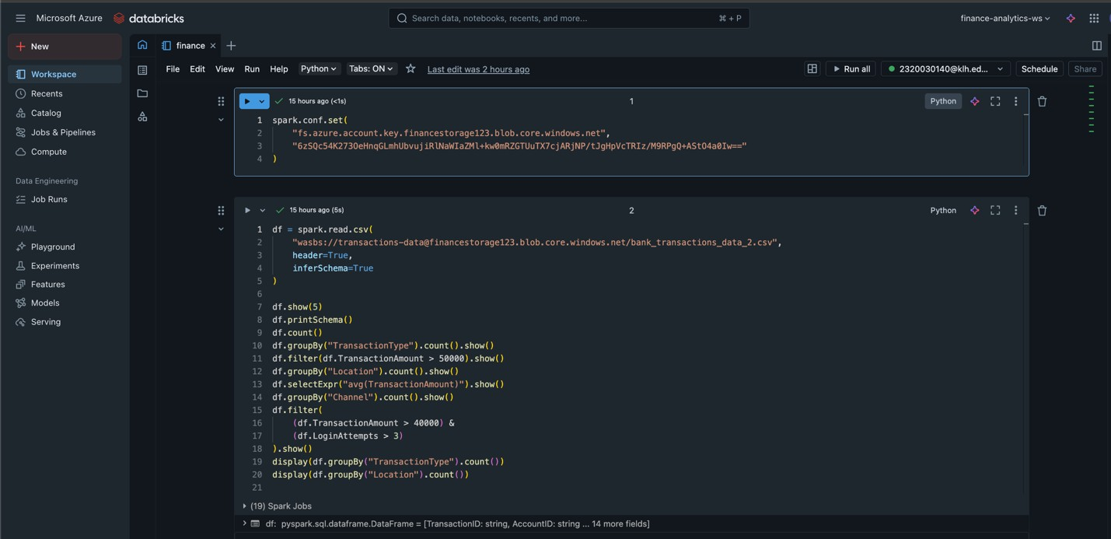
  - Visualization: Bar charts and tables are used to display results.

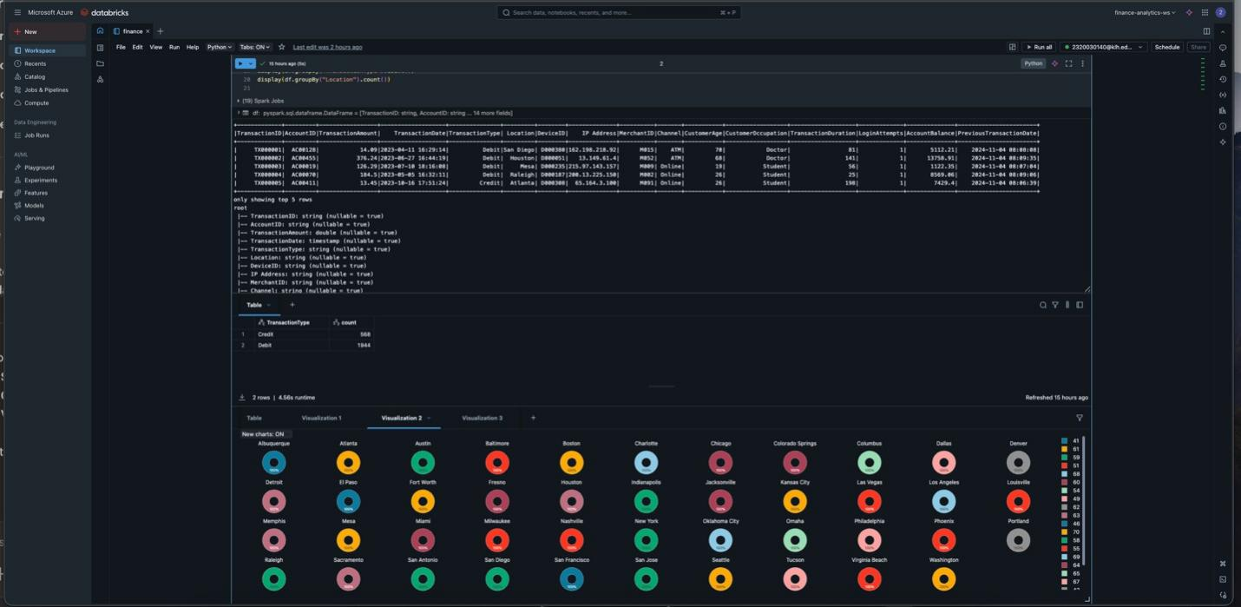

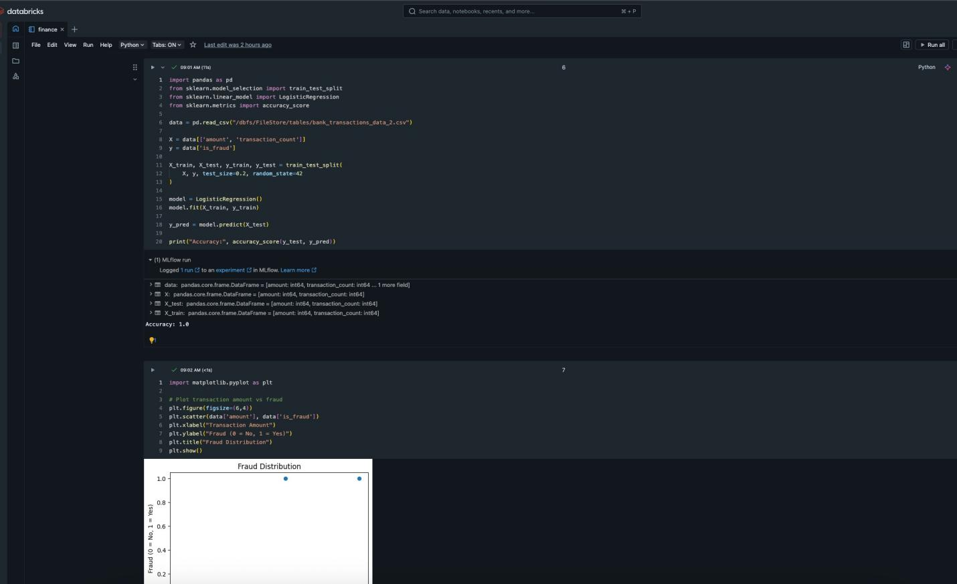
Experimentation

Steps Performed
- Loaded financial transaction dataset into Azure Databricks.

- Performed data cleaning and preprocessing.
- Analysed transaction patterns such as:
  - Debit vs Credit transactions
  - Location-wise transactions
  - Channel-based usage
- Detected high-value and suspicious transactions.
- Applied a basic machine learning model (Logistic Regression) for fraud detection.
- Visualized results using charts.

Performance Analysis

- Processing Speed: Fast due to cloud-based Spark processing
- Scalability: Handled large datasets efficiently
- Accuracy: Successfully identified suspicious transactions
- Resource Usage: Minimal local resource usage due to cloud execution

Conclusion of Experimentation

The experimentation proved that cloud-based analytics using Azure Databricks is efficient and reliable for financial transaction analysis. The system successfully identified transaction patterns and suspicious activities. The results show that cloud computing provides better scalability, performance, and flexibility compared to traditional systems.

RESULT

Results of the Cloud-Based Financial Transaction Analytics Project

The implementation of the Cloud-Based Financial Transaction Pattern Analytics system produced meaningful results that demonstrate the effectiveness of cloud computing in handling and analysing large financial datasets. The project successfully analysed transaction data using Azure Blob Storage and Azure Databricks, enabling efficient processing, pattern detection, and visualization of financial transactions. The results obtained from the system highlight the usefulness of cloud-based analytics in identifying transaction trends, detecting suspicious activities, and supporting decision-making in financial environments.

Transaction Pattern Analysis

The system analysed transaction data to understand customer behaviour and spending patterns. The following observations were obtained:
  - Debit transactions were significantly higher than credit transactions, indicating that most customers use their accounts primarily for payments and purchases.
  - Transaction analysis based on location showed variations in transaction volume across different cities, highlighting areas with higher financial activity.
  - Channel-based analysis (ATM, Online, POS) revealed that online transactions dominate, reflecting the growing trend of digital banking.

These results demonstrate the effectiveness of cloud-based analytics in extracting meaningful insights from large datasets.

High-Value and Suspicious Transaction Detection

One of the major objectives of the project was to identify suspicious or high-risk transactions. This was achieved by analysing:
  - Transaction amount
  - Number of login attempts
  - Account balance patterns

Transactions with unusually high amounts and multiple login attempts were flagged as potential fraud cases.

This rule-based analysis helped in identifying abnormal patterns that may indicate fraudulent behaviour. The system successfully demonstrated how financial institutions can monitor suspicious transactions using cloud analytics.

Performance Evaluation

Time Efficiency

The use of Azure Databricks enabled fast processing of large datasets using distributed computing. Data analysis tasks that would normally take longer on traditional systems were completed efficiently due to Spark’s parallel processing capability.

Scalability

The cloud-based environment allowed the system to scale easily with increasing data size. Unlike traditional systems, the processing performance remained stable even when handling large volumes of transaction data.

Visualization and Insight Generation

The visualization component played a key role in interpreting the results. Various charts were generated using Azure Databricks:

  - Bar charts showing debit and credit transaction distribution
  - Pie charts representing transaction channels
  - Location-based graphs displaying transaction frequency
  - Tables showing high-value and suspicious transactions

These visual representations made it easier to understand complex data patterns and supported quick decision-making.

Machine Learning-Based Observations

A basic machine learning approach using Logistic Regression was implemented to classify transactions as normal or suspicious. The model used transaction amount, login attempts, and account balance as input features.
The model successfully:

  - Identified high-risk transactions

  - Classified transactions based on risk
  - Demonstrated the applicability of ML in financial fraud detection

Although a simple model was used, the results showed that machine learning can significantly enhance fraud detection accuracy when integrated with cloud analytics.

Learning Outcomes

Through this project, the following key learnings were achieved:

  - Understanding of cloud-based data storage and processing
  - Practical exposure to Azure Databricks and Spark
  - Knowledge of financial transaction analysis
  - Hands-on experience with data visualization
  - Understanding the role of machine learning in fraud detection
  - Awareness of the importance of scalability and performance in financial systems

Final Overview

The results of the project clearly demonstrate that cloud-based analytics is an efficient and reliable approach for financial transaction analysis. Azure Databricks proved to be a powerful platform for handling large datasets, performing analytics, and generating meaningful insights. The system effectively identified transaction patterns, detected suspicious activities, and presented results in a visually understandable manner.

Overall, the project successfully achieved its objectives and demonstrated how cloud computing, data analytics, and machine learning can be integrated to build a scalable and efficient financial transaction analysis system. The outcomes of this project highlight its relevance in real-world banking and financial applications and provide a strong foundation for further enhancements such as real-time fraud detection and advanced machine learning models.

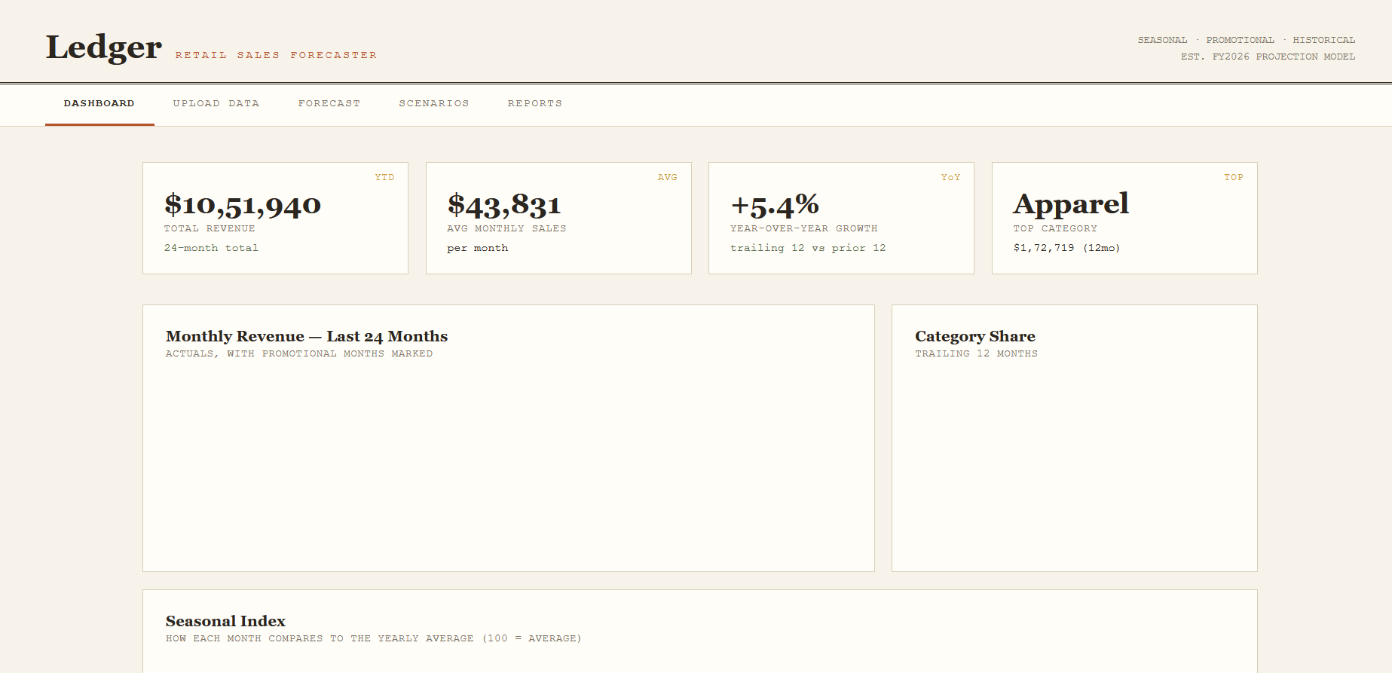
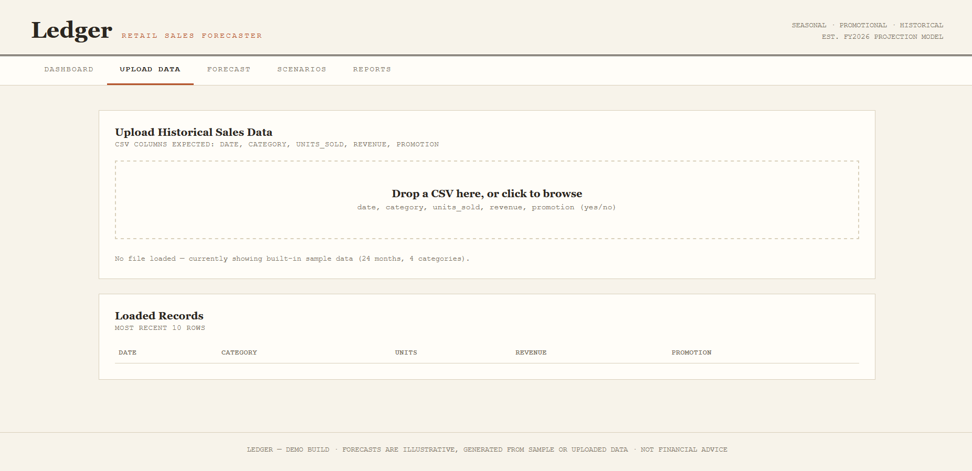
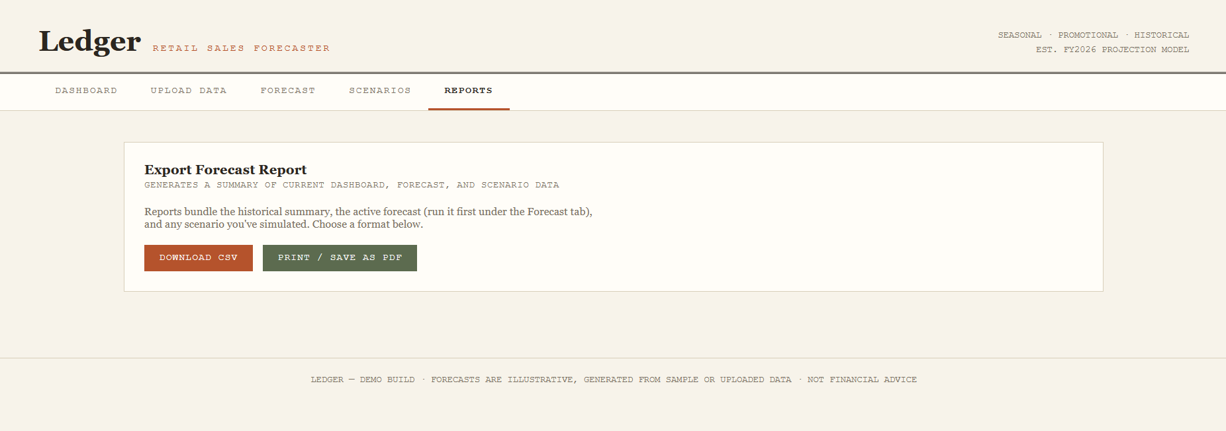

CONCLUTION

The Cloud-Based Financial Transaction Pattern Analytics project successfully demonstrated how cloud computing can be effectively used to analyse large volumes of financial data. By utilizing Microsoft Azure services such as Azure Blob Storage and Azure Databricks, the project showcased a scalable and efficient approach to handling, processing, and analysing transaction data. The system was able to extract meaningful insights related to transaction patterns, customer behaviour, and potential fraudulent activities.
Through the implementation of data analytics techniques, the project highlighted how financial transactions can be categorized based on transaction type, location, channel, and transaction amount. The identification of high-value and suspicious transactions demonstrated the importance of analytics in fraud detection and risk management. The use of visualization techniques further enhanced the understanding of complex data by presenting it in an intuitive and interpretable manner.

The integration of a basic machine learning model provided an additional layer of intelligence to the system by enabling the classification of transactions as normal or suspicious. This showed how cloud-based platforms can support advanced analytical and predictive capabilities with minimal infrastructure requirements.

Overall, the project successfully met its objectives by demonstrating the practical application of cloud computing in financial analytics. It provided valuable insights into how modern financial institutions can leverage cloud technologies for scalable data processing, improved decision-making, and enhanced security. The project also emphasized the importance of cloud-based solutions in handling real-world financial data efficiently and reliably.

This work serves as a strong foundation for future enhancements such as real-time transaction monitoring, advanced fraud detection using machine learning models, and integration with live financial systems, thereby making it highly relevant for real-world financial applications.

REFRENCES

References

- Microsoft Azure Documentation

Microsoft Azure. Azure Blob Storage Documentation.

Available at: https://learn.microsoft.com/en-us/azure/storage/blobs/

This reference was used to understand cloud-based storage, data security, and integration with analytics services.

Azure Databricks Documentation

Microsoft Azure. Azure Databricks Overview and Tutorials. Available at: https://learn.microsoft.com/en-us/azure/databricks/
This source provided guidance on data processing, Spark-based analytics, and visualization techniques used in the project.

Python Official Documentation

Python Software Foundation. Python Documentation. Available at: https://docs.python.org/3/
Referenced for Python programming concepts and data handling techniques used in the project.

Fraud Detection in Financial Transactions

Bolton, R. J., & Hand, D. J. (2002). Statistical Fraud Detection: A Review. This research provided insight into transaction behaviour analysis and fraud detection techniques.

Big Data Analytics in Finance

Chen, M., Mao, S., & Liu, Y. (2014). Big Data: A Survey. This paper helped in understanding the role of big data analytics in financial applications.

Data Visualization Techniques

Few, S. (2009). Now You See It: Simple Visualization Techniques for Quantitative Analysis. This reference helped in understanding the importance of visualization for data interpretation.

Cloud Computing Concepts

Armbrust, M., et al. (2010). A View of Cloud Computing. Communications of the ACM.Provided theoretical background on cloud computing and its advantages.

Online References

- https://learn.microsoft.com/en-us/azure/

- ​https://learn.microsoft.com/en-us/azure/databricks/

- ​https://spark.apache.org/

- ​https://www.kaggle.com (for financial transaction datasets)

- ​https://towardsdatascience.com (for analytics and ML concepts)

- ​https://www.geeksforgeeks.org (for Python and data analytics reference)

